EXPT NO:5 | DEVELOP INTERACTIVE DASHBOARDS FOR DYNAMIC DATA EXPLORATION USING TABLEAU AND POWERBI
DATE: 24.07.2026

PRE-LAB QUESTIONS (PROVIDE BRIEF ANSWERS TO THE FOLLOWING QUESTIONS)

- What is dynamic data exploration in BI tools, and why is it important?
Dynamic data exploration is the process of interactively analyzing data by applying filters slicers drill down features and other controls to discover patterns and trends. It allows users to view information from different perspectives without creating multiple reports. This approach helps analysts answer business questions quickly and supports better decision making. Dynamic exploration also makes dashboards more flexible because users can customize the displayed information according to their specific analysis requirements and objectives.

- What are slicers and filters, and how do they enhance dashboard interactivity?
Slicers and filters are interactive tools that allow users to display only the data that matches selected conditions. Filters are commonly applied to worksheets or dashboards while slicers provide a visual interface for selecting values such as categories regions or dates. They improve dashboard interactivity by allowing users to focus on specific information without modifying the original dataset. This makes reports easier to explore and enables faster comparisons between different groups periods and business metrics.

- How do Tableau and Power BI support drill-down and drill-through features?
Tableau and Power BI support drill down features that allow users to move from summarized information to detailed records. For example users can explore sales data from yearly totals to quarterly monthly and daily values. Power BI also provides drill through functionality that opens a separate report page with detailed information related to a selected value. These features simplify analysis by helping users identify trends investigate problems and understand the underlying details behind summary visualizations.

- What is the role of parameters in creating interactive dashboards?
Parameters are user controlled values that make dashboards more flexible and interactive. They allow users to change calculations switch between measures adjust chart displays or modify analysis without editing the report itself. In Tableau parameters can be connected to calculated fields while Power BI provides similar functionality through field parameters and dynamic measures. Parameters improve the user experience by giving greater control over the dashboard and allowing different analytical views within a single report.

- Name some advanced interactivity features in Tableau and Power BI.
Tableau and Power BI provide many advanced features that improve dashboard interactivity and user experience. These include filters slicers drill down drill through parameters bookmarks highlight actions tooltips and cross filtering between visualizations. Interactive maps and dynamic hierarchies also help users explore data from different perspectives. These features enable users to investigate trends compare values and obtain detailed insights while making dashboards more engaging efficient and suitable for business decision making.

IN-LAB EXERCISE:
OBJECTIVE:
To design and develop interactive dashboards in Tableau and Power BI for dynamic data exploration, enabling users to analyze, filter, and drill down into data for deeper insights.
PROCEDURE:
- Data Collection:
    - Import datasets from sources such as Excel, CSV, SQL Server, or online APIs.
    - Dataset: Retail Sales Dataset with fields such as Order Date, Region, Product Category, Sales, Profit, Quantity.
- Data Preparation and Transformation:
    - Ensure proper date formats for time-based analysis. o Handle missing or incorrect values.
    - Create calculated fields (e.g., Profit Margin %, Sales Growth %, Year-to-Date Sales).
- Data Aggregation and Hierarchies:
    - Create hierarchies (e.g., Year → Quarter → Month → Day).
    - Aggregate data by region, product category, or customer segment.
- Designing Interactive Elements:
    - Filters & Slicers: Allow filtering by product category, date range, or region. o Parameters: Let users switch between KPIs (e.g., Sales vs. Profit). o Drill-down: Enable users to explore data from summary to detail.
    - Tooltips: Add contextual details when hovering over data points.
- Dashboard Development:
    - Tableau: Use interactive filters, parameter controls, and highlight actions.
    - Power BI: Use slicers, bookmarks, and drill-through pages.
    - Add KPI cards for key metrics like Total Sales, Total Profit, Top Selling Product. o Use maps for regional sales analysis, line charts for trends, and bar charts for category comparisons.
- Testing Interactivity:
    - Ensure slicers and filters update all relevant visuals dynamically.
    - Test drill-down and drill-through functionality for accuracy.
- Publishing and Sharing:
    - Tableau: Publish on Tableau Public or Tableau Server.
    - Power BI: Publish to Power BI Service and share via workspace access or public link.
Experiment Dataset:
Retail Sales Dataset
Fields Used:
  - Order Date – Date of the order
  - Region – Sales region
  - Product Category – Category of product sold
  - Sales – Sales revenue
  - Profit – Net profit from the order
  - Quantity – Units sold

Screenshot of Tableau

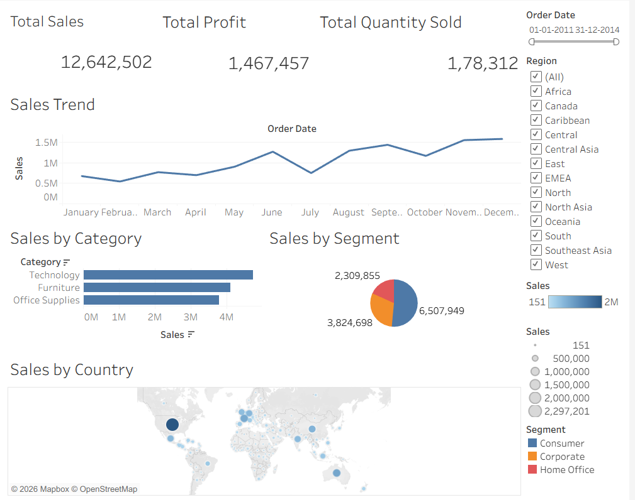
Screenshot of Power BI

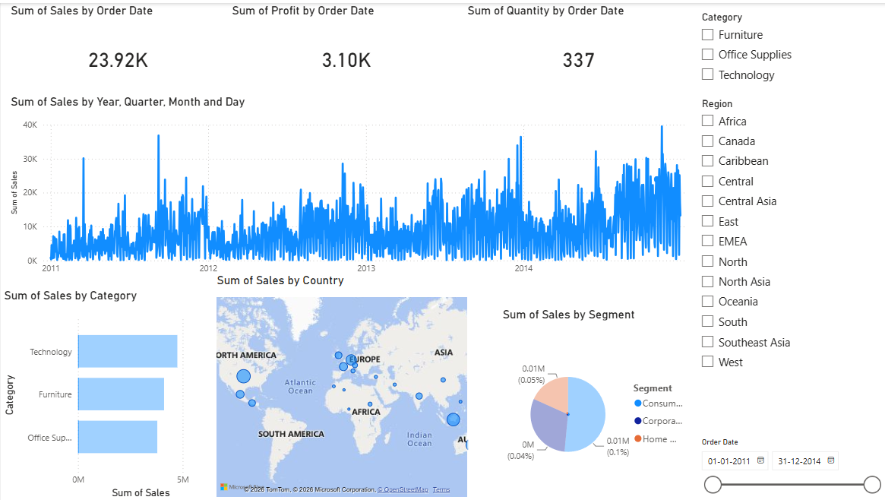

POST-LAB QUESTIONS (PROVIDE BRIEF ANSWERS TO THE FOLLOWING QUESTIONS)

- How did interactivity improve the analysis experience in your dashboard?
Interactivity significantly improved the dashboard by allowing users to explore the sales data from multiple perspectives without creating separate reports. Filters slicers and drill down features made it possible to focus on selected regions categories and time periods instantly. This provided faster access to relevant information and made comparisons between different business metrics much easier. Interactive dashboards also improved user engagement because changes were reflected immediately across all visualizations making analysis more efficient and meaningful

- Which interactive feature (filters, drill-down, parameters, etc.) was most useful and why?
The most useful interactive feature was the slicer because it allowed the dashboard to display information based on selected regions categories and order dates. By selecting different values users could instantly update every visualization on the dashboard without changing the original data. This simplified analysis and made it easier to compare sales profit and quantity across different business segments. Slicers also improved the flexibility of the dashboard and supported quicker decision making through interactive exploration.

- What challenges did you face while implementing drill-down or dynamic filters?
One of the main challenges was configuring the drill down hierarchy correctly so that users could move from yearly data to quarterly monthly and daily information. Another challenge was ensuring that filters updated all charts consistently across the dashboard. These issues were resolved by applying filters to all worksheets and verifying that every visualization responded correctly to user selections. Testing the dashboard carefully ensured accurate and smooth interactive analysis throughout the report.

- How do tooltips contribute to better dashboard storytelling?
Tooltips improve dashboard storytelling by providing additional information when users move the pointer over charts and graphs. They display important details such as sales profit quantity region and category without overcrowding the visualizations. This allows users to understand the context behind each data point while keeping the dashboard clean and organized. Tooltips also encourage deeper exploration because users can quickly access detailed information without navigating to another report or worksheet.

- What additional features would you add to make the dashboard more insightful?
The dashboard could be improved by adding forecasting trend analysis KPI comparisons and additional calculated measures such as profit margin and sales growth. Drill through pages and custom tooltips would provide more detailed information for selected products or regions. Conditional formatting and advanced maps would further improve visualization quality. Integrating customer level analysis and predictive analytics would provide deeper business insights and make the dashboard more useful for strategic decision making.

RESULT:

The retail sales dataset was successfully transformed, aggregated, and visualized into interactive dashboards in Tableau and Power BI. Filters, slicers, drill-downs, and parameters enabled dynamic exploration of sales and profit trends by region, product category, and time period. The resulting dashboards allowed for quick insights and deeper analysis, enhancing decision-making capabilities.

ASSESSMENT

Description |  | Max Marks | Marks Awarded
Pre Lab Exercise |  | 5
In Lab Exercise |  | 10
Post Lab Exercise |  | 5
Viva |  | 10
 | Total | 30
 | Faculty Signature

